Night Prayer
Compline

Almighty God grant us a quiet night and peace at the last.
Amen.

Night Hymn
“All praise to thee, my God, this night” (#565) or another night hymn may be sung.
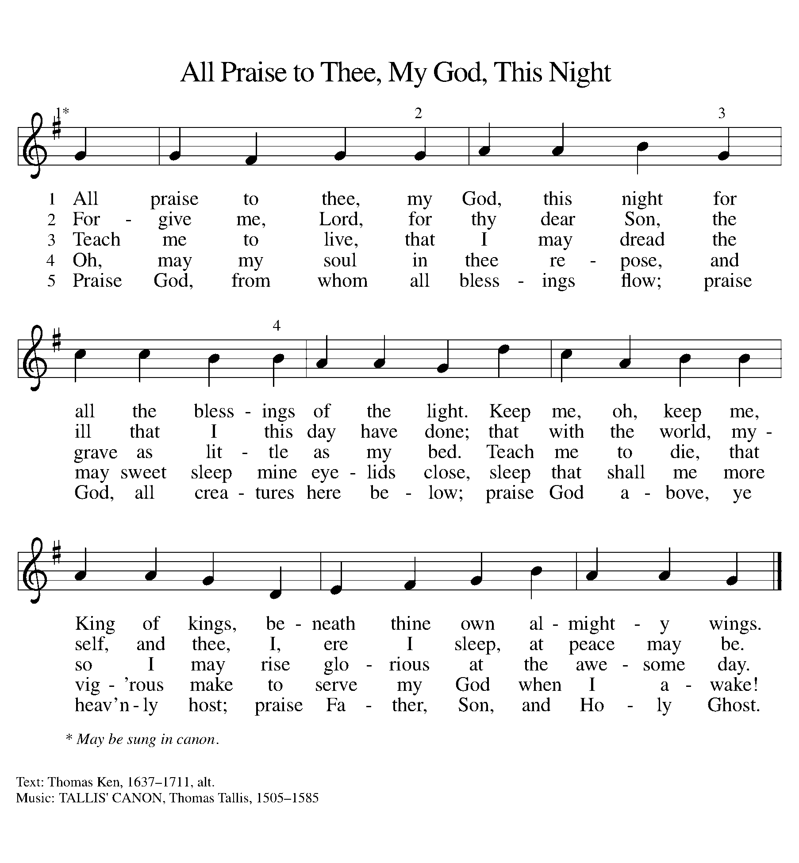
Confession and Forgiveness
A leader in a group setting invites them to cofession
Let us confess our sin in the presence of God and of one another.
silence for self-examination.
Holy and gracious God,
I confess that I have sinned against you this day.
Some of my sin I know—
the thoughts and words and deeds
of which I am ashamed—
but some is known only to you.
In the name of Jesus Christ I ask forgiveness.
Deliver and restore me,
that I may rest in peace.
By the mercy of God
we are united with Jesus Christ,
in whom we are forgiven.
We rest now in the peace of Christ
and rise in the morning to serve.
.

Psalmody
One or more psalms (such as 4, 33, 34, 91, 130, 134, 136) are sung or said.
ELW Psalm 4
¹Answer me when I call, O God, defender | of my cause;
you set me free when I was in distress; have mercy on me and | hear my prayer.
²“You mortals, how long will you dishon- | or my glory;
how long will you love illusions and seek | after lies?”
³Know that the Lord does wonders | for the faithful;
the Lord will hear me | when I call.
⁴Tremble, then, and | do not sin;
speak to your heart in silence up- | on your bed.
⁵Offer the appointed | sacrifices,
and put your trust | in the Lord.
⁶Many are saying, “Who will show us | any good?”
Let the light of your face shine upon | us, O Lord.
⁷You have put gladness | in my heart,
more than when grain and | wine abound.
⁸In peace, I will lie | down and sleep;
for you alone, O Lord, make me | rest secure.

ELW Psalm 33
¹Rejoice in the | Lord, you righteous;
praise is fitting | for the upright.
²Praise the Lord | with the lyre;
make music for God with a | ten-stringed harp.
³Sing for the Lord | a new song;
play your instrument skillfully with | joyful sounds.
⁴For your word, O | Lord, is right,
and faithful are | all your works.
⁵You love righteous- | ness and justice;
your steadfast love fills | the whole earth.
⁶By your word were the | heavens made,
by the breath of your mouth all the | hosts of heaven.
⁷You gather up the waters of the ocean as | in a water-skin
and store up the depths | of the sea.
⁸Let all the earth | fear the Lord;
let all who dwell in the world | stand in awe.
⁹For God spoke, and it | came to pass;
God commanded, and | it stood fast.
¹⁰The Lord brings the will of the na- | tions to nothing
and thwarts the designs | of the peoples.
¹¹Your will, O Lord, stands | fast forever,
and the designs of your heart from | age to age.
¹²Happy is the nation whose God | is the Lord!
Happy the people chosen to | be God’s heritage!
¹³The Lord looks | down from heaven,
and sees all | humankind.
¹⁴God sits firmly en- | throned and watches
all who dwell | on the earth.
¹⁵God fashions | all their hearts
and observes | all their deeds.
¹⁶A king is not saved by the size | of the army,
nor are warriors rescued by | their great strength.
¹⁷The horse gives vain | hope for victory;
despite its great strength it | cannot save.
¹⁸Truly, your eye is upon those who fear | you, O Lord,
upon those who wait for your | steadfast love,
¹⁹to deliver their | lives from death,
and to keep them alive in | time of famine.
²⁰Our innermost being waits for | you, O Lord,
our helper | and our shield.
²¹Surely, our heart rejoic- | es in you,
for in your holy name we | put our trust.
²²Let your lovingkindness, O Lord, | be upon us,
even as we place our | hope in you.

ELW Psalm 34
¹I will bless the Lord | at all times;
the praise of God shall ever be | in my mouth.
²I will glory | in the Lord;
let the lowly hear | and rejoice.
³Proclaim with me the greatness | of the Lord;
let us exalt God’s | name together.
⁴I sought the Lord, who | answered me
and delivered me from | all my terrors.
⁵Look upon the Lord | and be radiant,
and let not your faces | be ashamed.
⁶I called in my affliction, and | the Lord heard me
and saved me from | all my troubles.
⁷The angel of the Lord encamps around those who | fear the Lord
and de- | livers them.
⁸Taste and see that the | Lord is good;
happy are they who take ref- | uge in God!
⁹Fear the Lord, you saints | of the Lord,
for those who fear the | Lord lack nothing.
¹⁰The lions are in want and | suffer hunger,
but those who seek the Lord lack nothing | that is good.
¹¹Come, children, and lis- | ten to me;
I will teach you reverence | for the Lord.
¹²Who among you takes plea- | sure in life
and desires long life to en- | joy prosperity?
¹³Keep your | tongue from evil
and your lips from | lying words.
¹⁴Turn from evil | and do good;
seek peace | and pursue it.
¹⁵The eyes of the Lord are up- | on the righteous,
and God’s ears are open | to their cry.
¹⁶The face of the Lord is against those | who do evil,
to erase the remembrance of them | from the earth.
¹⁷The righteous cry, and | the Lord hears them
and delivers them from | all their troubles.
¹⁸The Lord is near to the | brokenhearted
and saves those whose spir- | its are crushed.
¹⁹Many are the troubles | of the righteous,
but the Lord delivers them from | every one.
²⁰God will keep safe | all their bones;
not one of them | shall be broken.
²¹Evil will bring death | to the wicked
and those who hate the righteous | will be punished.
²²O Lord, you redeem the life | of your servants,
and those who put their trust in you will | not be punished.

ELW Psalm 130
¹Out | of the depths
I cry to | you, O Lord;
²O Lord, | hear my voice!
Let your ears be attentive to the voice of my | supplication.
³If you were to keep watch | over sins,
O Lord, | who could stand?
⁴Yet with you | is forgiveness,
in order that you | may be feared.
⁵I wait for you, O Lord; | my soul waits;
in your word | is my hope.
⁶My soul waits for the Lord more than those who keep watch | for the morning,
more than those who keep watch | for the morning.
⁷O Israel, wait for the Lord, for with the Lord there is | steadfast love;
with the Lord there is plen- | teous redemption.
⁸For the Lord shall | redeem Israel
from | all their sins.

Reading
The service includes one of the following or another brief scripture reading.
Jeremiah 14:9
You, O Lord, are in the midst of us, and we are called by your name; do not forsake us, O Lord our God. (Jeremiah 14:9)
Matthew 11:28-30
Come to me, all you that are weary and are carrying heavy burdens, and I will give you rest. Take my yoke upon you, and learn from me; for I am gentle and humble in heart, and you will find rest for your souls. For my yoke is easy, and my burden is light. (Matthew 11:28-30)
Romans 8:38-39
I am convinced that neither death, nor life, nor angels, nor rulers, nor things present, nor things to come, nor powers, nor height, nor depth, nor anything else in all creation, will be able to separate us from the love of God in Christ Jesus our Lord. (Romans 8:38-39)
Revelation 22:5
There will be no more night; the servants of God need no light of lamp or sun, for the Lord God will be their light, and they will reign forever and ever. (Revelation 22:5)
The reading of scripture is followed by extended silence for reflection and meditation. The silence may conclude with the following responsory.
Into your hands, O Lord, I commend my spirit.
Into your hands I commend my spirit.
You have redeemed me, O Lord, God of truth.
Into your hands I commend my spirit.
Glory to the Father, to the Son, and to the Holy Spirit.
Into your hands, I commend my spirit.

Prayers

Hear my prayer, O Lord;
listen to my cry.
Keep me as the apple of your eye;
hide me in the shadow of your wings.
In righteousness I shall see you;
when I awake, your presence will give me joy.
One or more of the following prayers or other appropriate prayers may be prayed.
Be present, merciful God, and protect us through the hours of this night, so that we who are wearied by the changes and chances of life may find our rest in you, through Jesus Christ our Lord.
Amen.
OR
O Lord, support us all the day long of this troubled life, until the shadows lengthen and the evening comes and the busy world is hushed, the fever of life is over, and our work is done. Then, in your mercy, grant us a safe lodging, and a holy rest, and peace at the last, through Jesus Christ our Lord.
Amen.
OR
Be our light in the darkness, O God, and in your great mercy defend us from all perils and dangers of this night; for the love of your only Son, our Savior Jesus Christ.
Amen.
OR
Keep watch, dear Lord, with those who work or watch or weep this night, and give your angels charge over those who sleep. Tend the sick, give rest to the weary, bless the dying, soothe the suffering, comfort the afflicted, shield the joyous; and all for your love’s sake.
Amen.
OR
Eternal God, the hours both of day and night are yours, and to you the darkness is no threat. Be present, we pray, with those who labor in these hours of night, especially those who watch and work on behalf of others. Grant them diligence in their watching, faithfulness in their service, courage in danger, and competence in emergencies. Help them to meet the needs of others with confidence and compassion; through Jesus Christ our Lord.
Amen.
OR
Gracious God, we give you thanks for the day, especially for the good we were permitted to give and to receive; the day is now past and we commit it to you. We entrust to you the night; we rest securely, for you are our help, and you neither slumber nor sleep; through Jesus Christ our Lord.
Amen.

Lord’s Prayer
Lord, remember us in your kingdom and teach us to pray.
Our Father in heaven,
hallowed be your name,
your kingdom come,
your will be done,
on earth as in heaven.
Give us today our daily bread.
Forgive us our sins
as we forgive those
who sin against us.
Save us from the time of trial
and deliver us from evil.
For the kingdom, the power,
and the glory are yours,
now and forever. Amen.
Gospel Canticle

The gospel canticle for night prayer is the song of Simeon, spoken using the words below or, if you have an ELW, using the following #200, 201, 202,203, 313, 440

Guide us waking, O Lord,
and guard us sleeping;
that awake we may watch with Christ
and asleep may rest in peace.
Now, Lord, you let your servant go in peace:
your word has been fulfilled.
My own eyes have seen the salvation
which you have prepared in the sight of ev'ry people:
a light to reveal you to the nations
and the glory of your people Israel.
Guide us waking, O Lord,
and guard us sleeping;
that awake we may watch with Christ
and asleep we may rest in peace.

Blessing

Let us bless the Lord
Thanks be to God.
Almighty and merciful God, Father, ☩ Son, and Holy Spirit,
bless, preserve, and keep us, this night and forevermore.
Amen.

OR

Now in peace I will lie down and sleep;
you alone, O God, make me secure.
Let us bless the Lord.
Thanks be to God.

