Morning Prayer
Matins

You may wish to set aside a bowl of water for remembrance of baptism

Satisfy us in the morning with your steadfast love, O God,
that we may rejoice and be glad all our days.
Praise to the blest and holy Trinity, one God,
who gives us life, salvation, and resurrection.
Alleluia!

Dipping your hand in the bowl of water, and/or making the sign of the cross (+), you may give thanks for baptism

Redeeming God, we give you thanks
that through the gift of baptism
you have clothed us in your grace
and made us heirs of your promise.
By the power of the Holy Spirit,
set us free from all that we fear
and let us live according to our faith;
through Jesus Christ our Savior. Amen.

Psalmody
The psalmody begins with a morning psalm of praise: Psalm 95:1-7a (the Venite) or, Psalm 100, or another appropriate psalm.
Psalm 95:1-7a
Give glory to God our light and our life.
O, come, let us worship God.
Come, let us sing to the Lord:
let us shout for joy to the rock of our salvation.
Let us come before God’s presence with thanksgiving
and raise a loud shout to the Lord with psalms.
For you, Lord, are a great God,
and a great ruler above all gods.
Come, let us sing to the Lord:
let us shout for joy to the rock of our salvation.
In your hand are the caverns of the earth;
the heights of the hills are also yours.
The sea is yours, for you made it;
and your hands have molded the dry land.
Come, let us sing to the Lord:
let us shout for joy to the rock of our salvation.
Come, let us worship and bow down;
let us kneel before the Lord our maker.
For the Lord is our God,
and we are the people of God’s pasture
and the sheep of God’s hand.
Come, let us sing to the Lord:
let us shout for joy to the rock of our salvation.

Glory to the Father, and to the + Son, and to the Holy Spirit.
As it was in the beginning is now and will be forever. Amen.

ELW Psalm 100
¹Make a joyful noise to the Lord, | all you lands!
²Serve the Lord with gladness; come into God’s presence | with a song.
³Know that the Lord is God, our maker to whom | we belong;
we are God’s people and the sheep | of God’s pasture.
⁴Enter the gates of the Lord with thanksgiving and the | courts with praise;
give thanks and bless God’s | holy name.
⁵Good indeed is the Lord, whose steadfast love is | everlasting,
whose faithfulness endures from | age to age.
The following Psalm prayer may be said following a period of silence
God, we come to with thanksgiving and praise, for you have created us as your people and you sustain us with your hand. Nourish us in your rich pasture and keep us in your steadfast love, that we may bless your name and serve you with gladness day after day; through Jesus Christ, our Savior and Lord. Amen.

SonG
Choosing from below, additional songs may be sung.
#555
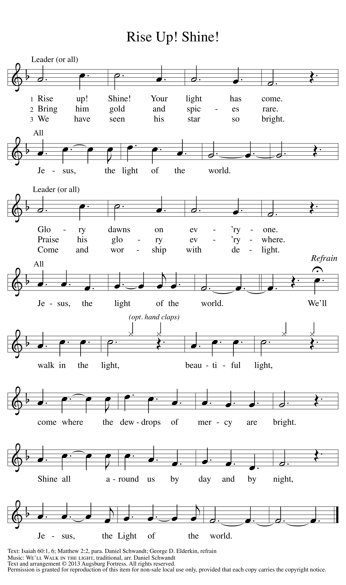

#557
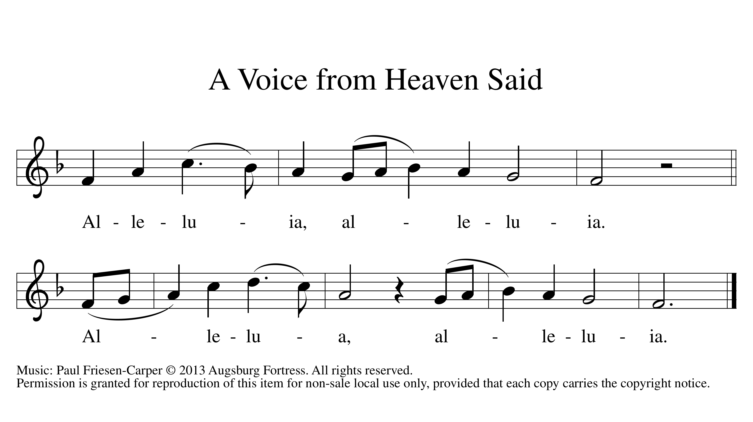

Readings

You may choose to read a lesson from the daily lectionary, followed by:
You have been born anew
through the living and abiding word of God.

Gospel Canticle
The song of Zechariah may be said below, or you may sing the hymn version below.
Blessed are you, Lord, the God of Israel,
you have come to your people and set them free.
You have raised up for us a mighty Savior,
born of the house of your servant David.
In the tender compassion of our God
the dawn from on high shall break upon us.
Through your holy prophets,
you promised of old to save us from our enemies,
from the hands of all who hate us,
to show mercy to our forebears,
and to remember your holy covenant.
This was the oath you swore to our father Abraham:
to set us free from the hands of our enemies,
free to worship you without fear,
holy and righteous before you, all the days of our life.
In the tender compassion of our God
the dawn from on high shall break upon us.
And you, child, shall be called the prophet of the Most High,
for you will go before the Lord to prepare the way,
to give God's people knowledge of salvation
by the forgiveness of their sins.
In the tender compassion of our God
the dawn from on high shall break upon us,
to shine on those who dwell in darkness and the shadow of death,
and to guide our feet into the way of peace.
In the tender compassion of our God
the dawn from on high shall break upon us.

#552
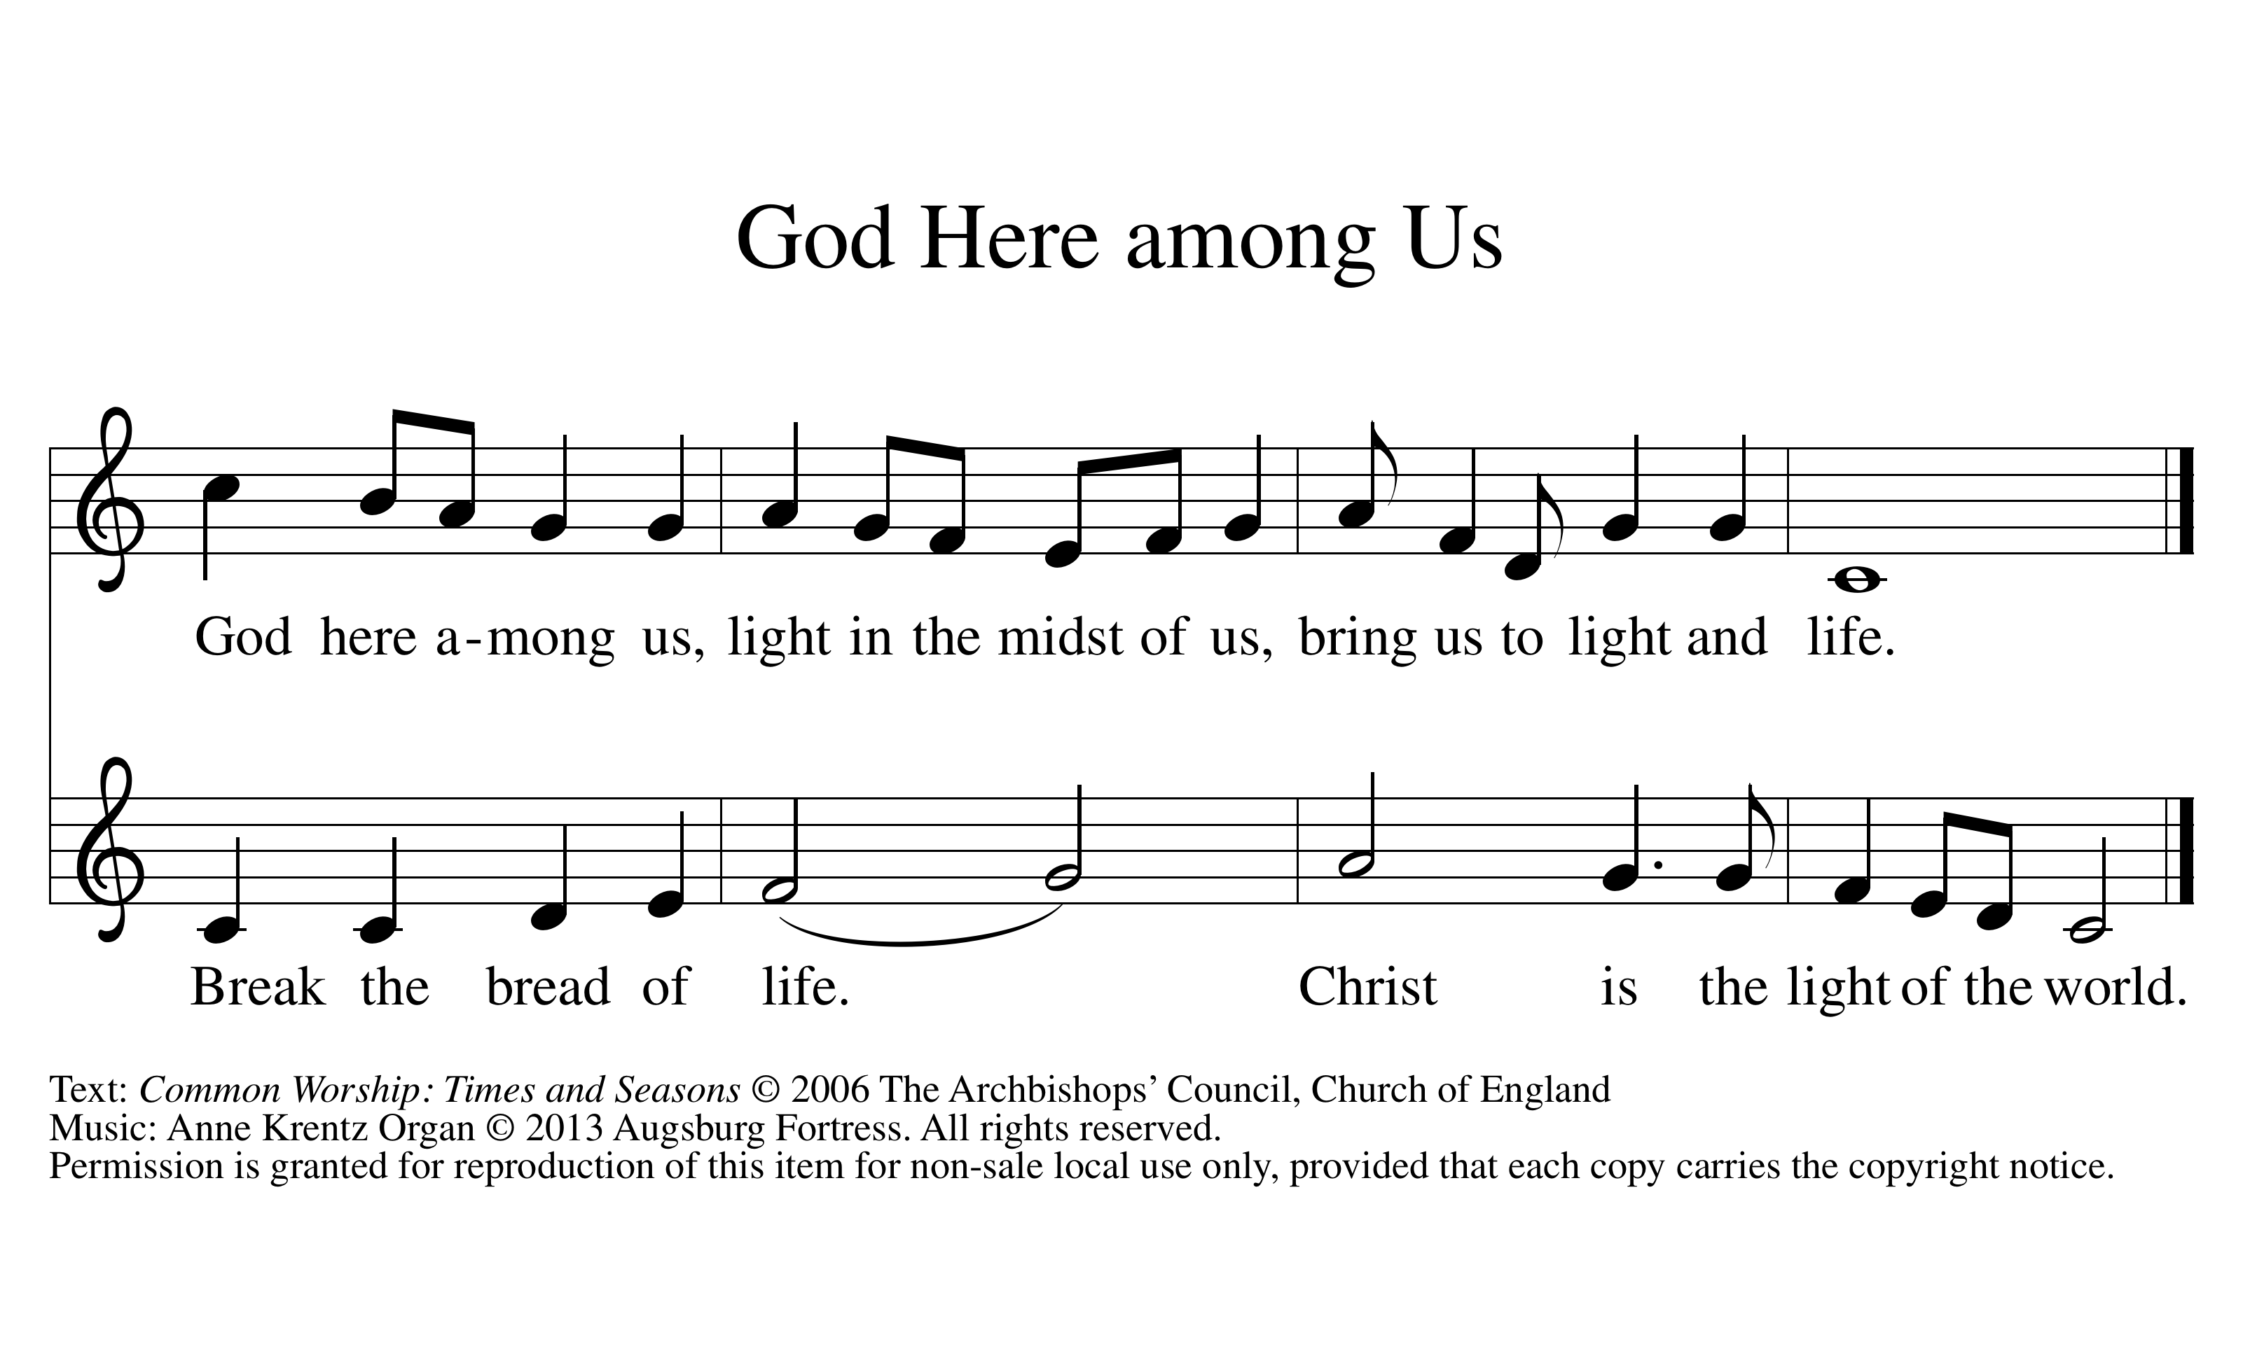

Prayers
A brief silence for prayer follows each petition.
Mighty God of mercy, we thank you for the resurrection dawn, bringing the glory of our risen Lord who makes every day new.
Especially we thank you—
for the sustaining goodness of your creation . . .
for the new creation in Christ and all gifts of healing and forgiveness . . .
for the gifts of relationship with others . . .
for the communion of faith in your church . . .
Other thanksgivings may be added.
Merciful God of might, renew this weary world, heal the hurts of all your children, and bring about your peace for all in Christ Jesus, the living Lord.
Especially we pray—
for those who govern nations of the world . . .
for the people in countries ravaged by strife or warfare . . .
for all who work for peace and international harmony . . .
for all who strive to save the earth from carelessness and destruction . . .
for the church of Jesus Christ in every land . . .
Other intercessions may be added.
One or more of the following prayers and other appropriate prayers may be used.
Almighty and everlasting God, you have brought us in safety to this new day. Preserve us with your mighty power, that we may not fall into sin nor be overcome in adversity. In all we do, direct us to the fulfilling of your purpose; through Jesus Christ our Lord.
Amen.
OR
O God, you have called your servants to ventures of which we cannot see the ending, by paths as yet untrodden, through perils unknown. Give us faith to go out with good courage, not knowing where we go, but only that your hand is leading us and your love supporting us; through Jesus Christ our Lord.
Amen.

Lord’s Prayer
Our Father in heaven,
hallowed be your name,
your kingdom come,
your will be done,
on earth as in heaven.
Give us today our daily bread.
Forgive us our sins
as we forgive those
who sin against us.
Save us from the time of trial
and deliver us from evil.
For the kingdom, the power,
and the glory are yours,
now and forever. Amen.
and the glory are yours,
now and forever. Amen.

Blessing
Let us bless the Lord.
Thanks be to God.

Almighty God, the Father, ☩ the Son, and the Holy Spirit, bless and preserve us.
Amen.

