Evening Prayer
Vespers

You are invited to light a candle.
God is our light and our salvation,
our refuge and our stronghold.
From the rising of the sun to its setting,
we praise your name, O God.
For with you is the fountain of life,
and in your light, we see light.
We give you thanks, O God,
for in the beginning, you called light into being,
and you set light in the sky
to govern night and day.
In a pillar of cloud by day
and a pillar of fire by night
you led your people into freedom.
Enlighten our darkness by the light of your Christ:
may your Word be a lamp to our feet
and a light to our path;
for you are merciful,
and you love your whole creation,
and with all your creatures we give you glory,
through your Son Jesus Christ,
in the unity of the Holy Spirit,
now and forever. Amen.
Psalmody
The psalmody begins with Psalm 141, a song of forgiveness and protection.
Let my prayer rise before you as incense;
the lifting up of my hands as the evening sacrifice.
O Lord, I call to you; come to me quickly;
hear my voice when I cry to you.
Let my prayer rise before you as incense;
the lifting up of my hands as the evening sacrifice.
Set a watch before my mouth, O Lord,
and guard the door of my lips.
Let not my heart incline to any evil thing;
let me not be occupied in wickedness with evildoers.
But my eyes are turned to you, Lord God;
in you I take refuge.
Strip me not of my life.
Glory to the Father, and to the Son,
and to the Holy Spirit;
as it was in the beginning, is now,
and will be forever. Amen.
Let my prayer rise before you as incense;
the lifting up of my hands as the evening sacrifice.

Silence for reflection
Let the incense of our prayer ascend before you, O God, and let your loving-kindness descend upon us, that with purified hearts we may sing your praises with the church on earth and the whole heavenly host and may glorify you forever and ever. Amen.

Here you may wish to pray another psalm, either from the daily lectionary or one of your own choosing, followed by a time of silence.

Readings
Here you may read one or more of the lessons from the daily lectionary, followed by:
Long ago God spoke to our ancestors in many and various ways by the prophets,
but in these last days God has spoken to us by the Son.

Gospel Canticle
The canticle is the song of Mary. You may read below or sing one of the hymn versions below.
My soul proclaims the greatness of the Lord,
my spirit rejoices in God my Savior.
My soul proclaims the greatness of the Lord,
my spirit rejoices in God my Savior,
for you, Lord, have looked with favor on your lowly servant.
From this day all generations will call me blessed:
you, the Almighty, have done great things for me
and holy is your name.
My soul proclaims the greatness of the Lord,
my spirit rejoices in God my Savior.
You have mercy on those who fear you,
from generation to generation.
You have shown strength with your arm
and scattered the proud in their conceit,
casting down the mighty from their thrones
and lifting up the lowly.
My soul proclaims the greatness of the Lord,
my spirit rejoices in God my Savior.
You have filled the hungry with good things
and sent the rich away empty.
You have come to the aid of your servant Israel,
to remember the promise of mercy,
the promise made to our forebears,
to Abraham and his children forever.
My soul proclaims the greatness of the Lord,
my spirit rejoices in God my Savior.

#251
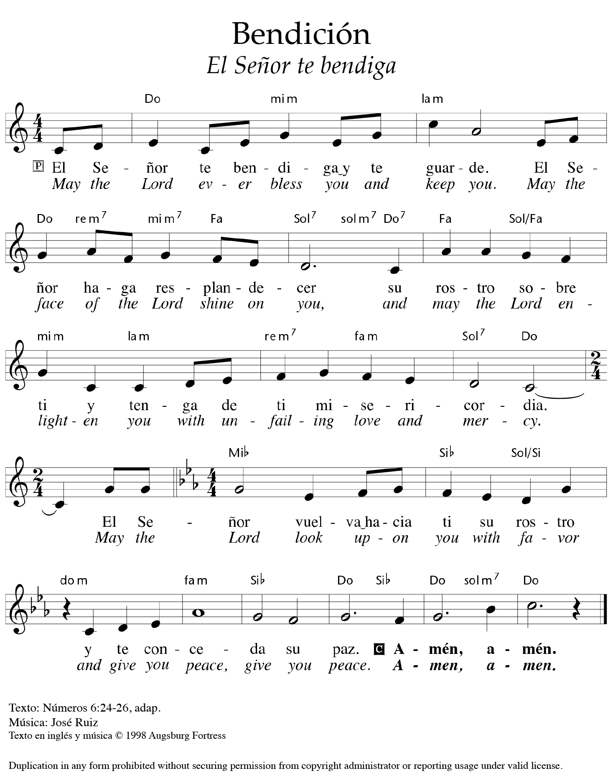

#723
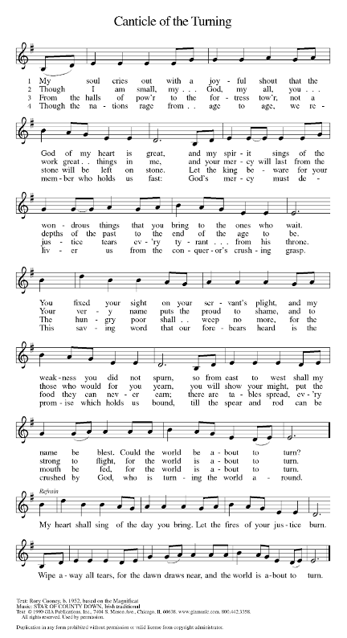

Prayers
In peace, let us pray to the Lord.
Lord, have mercy.
For the peace from above, and for our salvation, let us | pray to the Lord.
Lord, have mercy.
For the peace of the whole world, for the well-being of the church of God,
and for the unity of all, let us | pray to the Lord.
Lord, have mercy.
For this holy house, and for all who offer here their worship and praise,
let us | pray to the Lord.
Lord, have mercy.
For the health of the creation, for abundant harvests that all may share,
and for peaceful times, let us | pray to the Lord.
Lord, have mercy.
For public servants, the government, and those who protect us;
for those who work to bring peace, justice, healing, and protection
in this and every place, let us | pray to the Lord.
Lord, have mercy.
For those who travel, for those who are sick and suffering,
and for those who are in captivity, let us | pray to the Lord.
Lord, have mercy.
For deliverance in the time of affliction, wrath, danger, and need,
let us | pray to the Lord.
Lord, have mercy.
For all servants of the church, for our congregation,
and for all people who await from the Lord great and abundant mercy,
let us | pray to the Lord.
Lord, have mercy.
Other petitions may be added.
Help, save, comfort, and defend us, gracious Lord.
A time of silence follows.
Giving thanks for all who have gone before us and are at rest, rejoicing in the communion of all the saints, we commend ourselves, one another, and our whole life to you, through Christ our Lord.
Conclude the prayers with one of the following:
O God, you have called your servants to ventures of which we cannot see the ending, by paths as yet untrodden, through perils unknown. Give us faith to go out with good courage, not knowing where we go, but only that your hand is leading us and your love supporting us; through Jesus Christ our Lord. Amen.

OR
We give thanks to you, heavenly Father, through Jesus Christ your dear Son, that you have graciously protected us today. We ask you to forgive us all our sins, where we have done wrong, and graciously to protect us tonight. Into your hands we commend ourselves: our bodies, our souls, and all that is ours. Let your holy angels be with us, so that the wicked foe may have no power over us. Amen.

Lord’s Prayer
Our Father in heaven,
hallowed be your name,
your kingdom come,
your will be done,
on earth as in heaven.
Give us today our daily bread.
Forgive us our sins
as we forgive those
who sin against us.
Save us from the time of trial
and deliver us from evil.
For the kingdom, the power,
and the glory are yours,
now and forever. Amen.
Let us bless the Lord.
Thanks be to God.

Almighty God, the Father, ☩ the Son, and the Holy Spirit, bless and preserve me/us.
Amen.

